#### Cardiologic examination report

|  |  |
| --- | --- |
|  | **Date: 10.05.2021**  **---**  **Mr. John Stickler**  **« Jasper »**  DSH  male, 7 kg  Age: 6 yo |

**Dr. Theodoros SINANIS**

DVM, MSc, MRCVS

*Master of Science in Veterinary Internal Medicine,*

*Specially trained in Veterinary Cardiology at the*

*Cardiology Unit of Alfort, Paris- France*

*(École Nationale Vétérinaire d'Alfort)*

*European Society of Veterinary Cardiology member*

** Medical history – clinical examination**

**History :**

* Referring physician: **Dr. Ch. Kantzilieri.**
* Cardiologic examination in account of cardiac disease suspicion.
* Previous heart murmur auscultation.
* Radiographic examination: ND.
* Cardiac medication so far: **None.**

**Clinical findings** :

* Cardiac auscultation revealed a holosystolic, ejection type murmur, with a PMI at the left base of the heart, at the sternal area.
* Lung auscultation was unremarkable.
* No cough reproduction during tracheal palpation.
* Normal femoral pulse.
* Normal mucous membranes.
* No dental calculus.
* Normal body weight (BS: 3.5/5).
* Normal peripheral lymph nodes size.

 **Echocardiography exam results**

The examination was performed with cardiac single crystal phased array probes (P 2-9 & P 1-5 mHz).

|  |  |  |  |
| --- | --- | --- | --- |
| **Parameters** |  | **Parameters** |  |
| RVDd | 2.3 mm | Ao Vmax | 3.59 m/s |
| IVSd | 6.3 mm | P Vmax | 0.58 m/s |
| LVDd | 13.5 mm | Ant. mitral leaflet | - mm |
| PWd | 8.7 mm | Post. mitral leaflet | - mm |
| IVSs | 8.9 mm | IVs end-diastole SA | 6,8 mm |
| LVDs | 4.7 mm | Mitral E/A wave | 0.55/0.77 (0.72) 118 ms |
| PWs | 12.4 mm | RA/LA | 13.8/14.9 mm |
| FS | 65 % | Mit. Reg. Vmax | - m/s |
| LA- Ao | 14.4-11 mm | Tric. Reg. Vmax | - m/s |
| LA/Ao | 1.31 | PT/Ao | 1 |

## Interpretation

Περιγραφή: Περιγραφή: ac387 **Right parasternal and transventricular short-axis view (m-mode):**

* Moderate thickening of the LV free wall and interventricular septum.
* The contractility of the LV is WNL.
* Normal right ventricular dimensions.

Περιγραφή: Περιγραφή: ac387 **Left atrium examination presents:**

* The left atrial dimensions are normal at the end-systole.
* Mild regurgitant volume through the mitral valve, on colour flow Doppler examination.

Περιγραφή: ac387 **Right parasternal and transaortic short-axis view:**

* No anatomic lesions were found at the level of the pulmonary annulus.
* Normal pulmonic flow.
* No pulmonic regurgitation is present.

Περιγραφή: ac387 **Right parasternal long-axis four & five chamber views:**

* Normal mitral valve (anterior & posterior leaflet) appearance, no thickening nor prolapse are depicted.
* Normal right atrial dimensions.
* Normal right to left atrial ratio (RA/LA=0.9).
* Systolic anterior motion (**SAM**) of the mitral valve.
* No aortic regurgitation is present.
* No interventricular nor interatrial septal defect was found.

Περιγραφή: ac387 **Left parasternal long-axis four & five chamber views:**

* Turbulent aortic flow at the level of the aortic annulus.
* 1st degree LV diastolic dysfunction (E<A wave).
* No tricuspid regurgitation is present on colour-flow Doppler.

Περιγραφή: Περιγραφή: ac387 **Other points:**

* No pericardial nor pleural effusion is present.
* No pulmonary hypertension is present.
* No smoke effect or thrombus detected.
* Sinus rhythm (**sinus tachycardia**) during the examination. Heart rate: 120-128 bpm.

### Conclusions

* **Hypertrophic cardiomyopathy, obstructive form,** with moderate thickening of the LV free wall & the interventricular septum, normal LA dimensions & no congestion signs.
* Hypertrophic cardiomyopathy is the most common acquired feline heart disease and appears mostly in older cats, though younger can also be affected. It is characterized by myocardial thickening which may lead to congestive heart failure.
* A 2nd echocardiographic examination is recommended after 12 months (**May 2022**).
* **Cardiac medication :** not recommended.

**Yours sincerely:**

**Dr. Theodoros Sinanis**

[**theodsin@hotmail.com**](mailto:theodsin@hotmail.com)

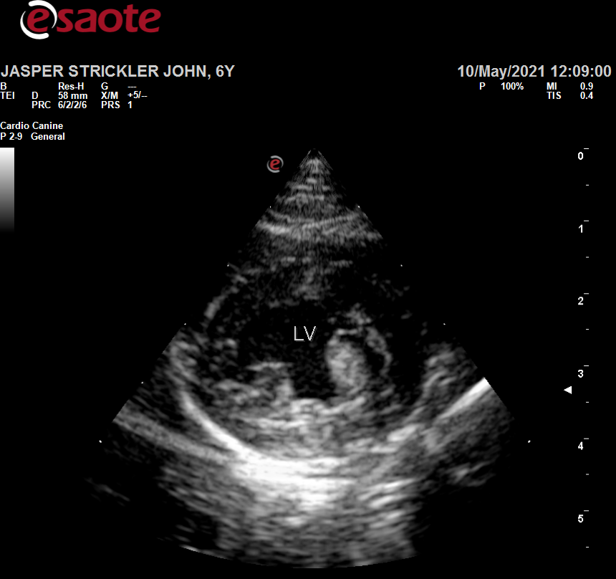 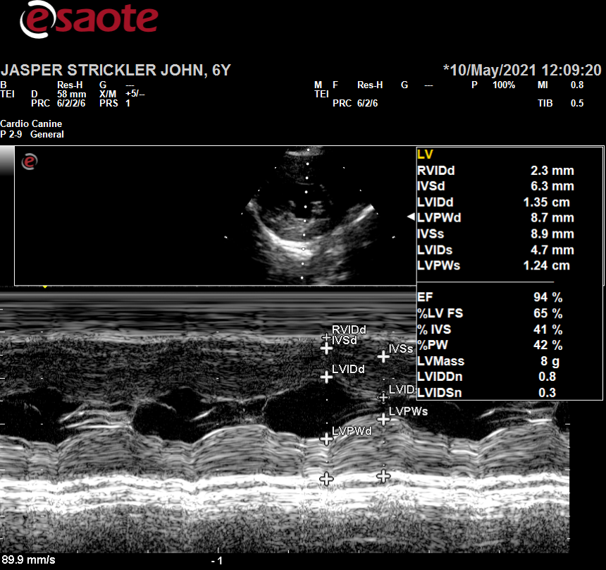

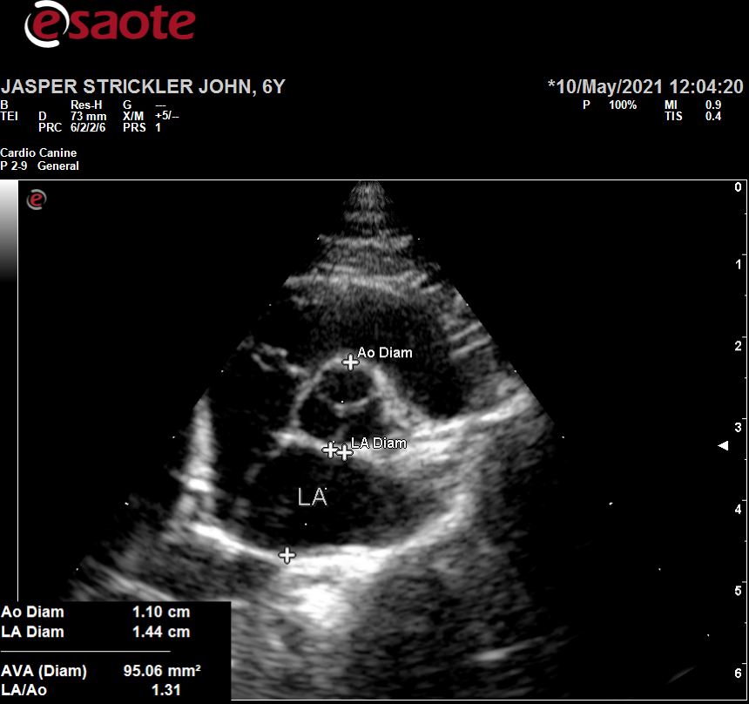 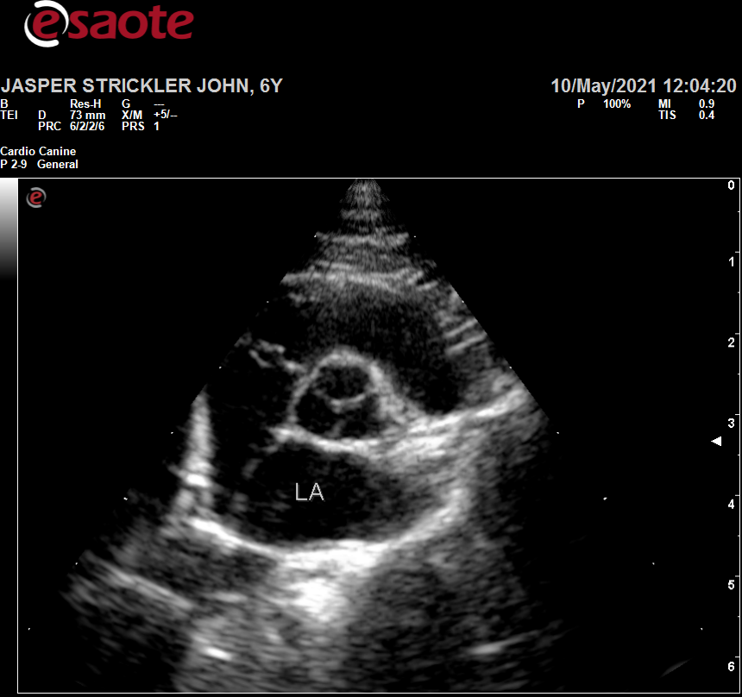

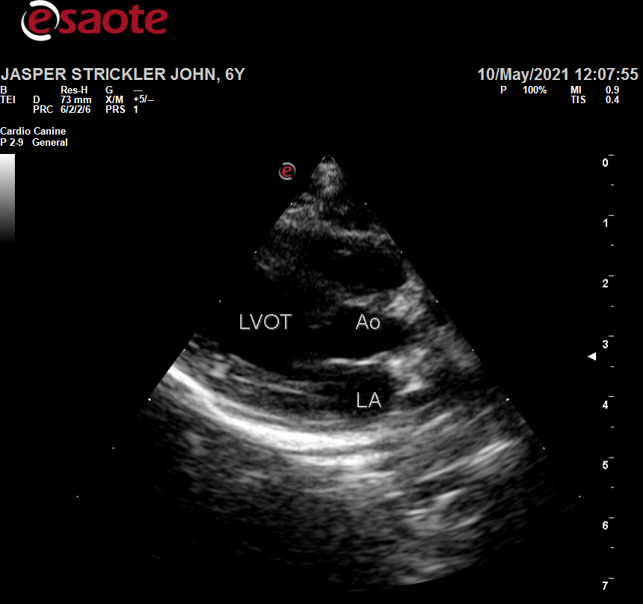 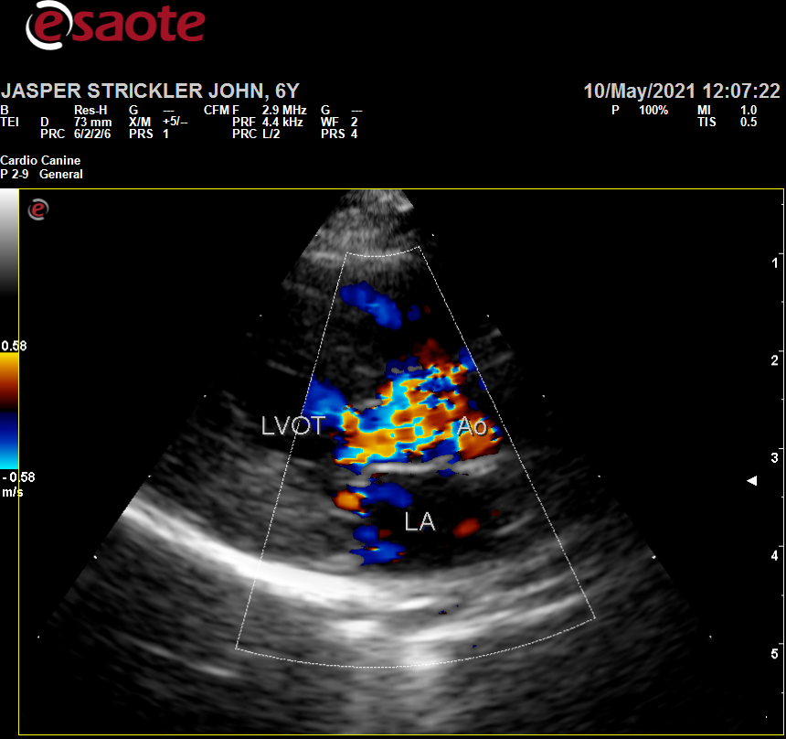

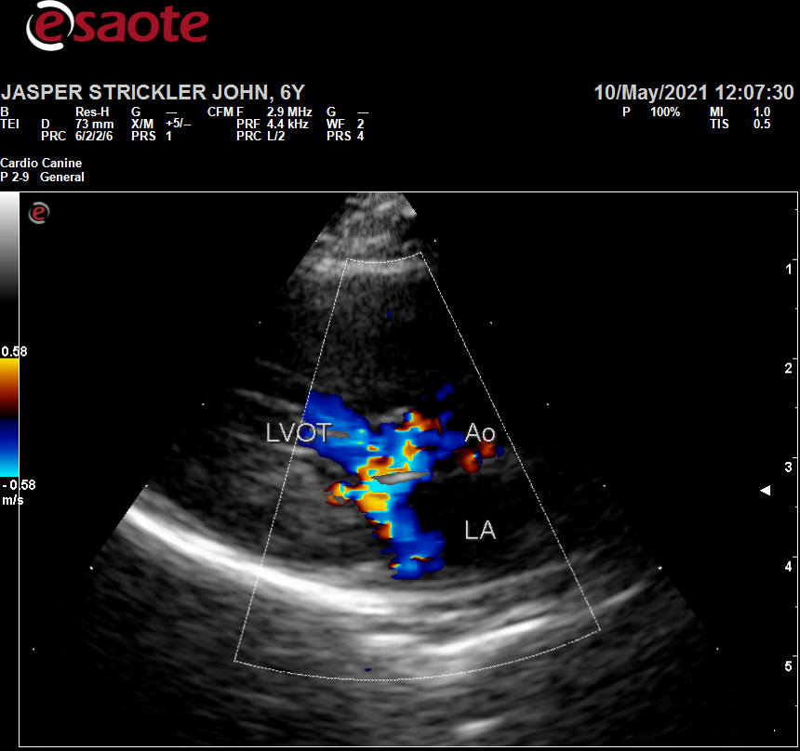 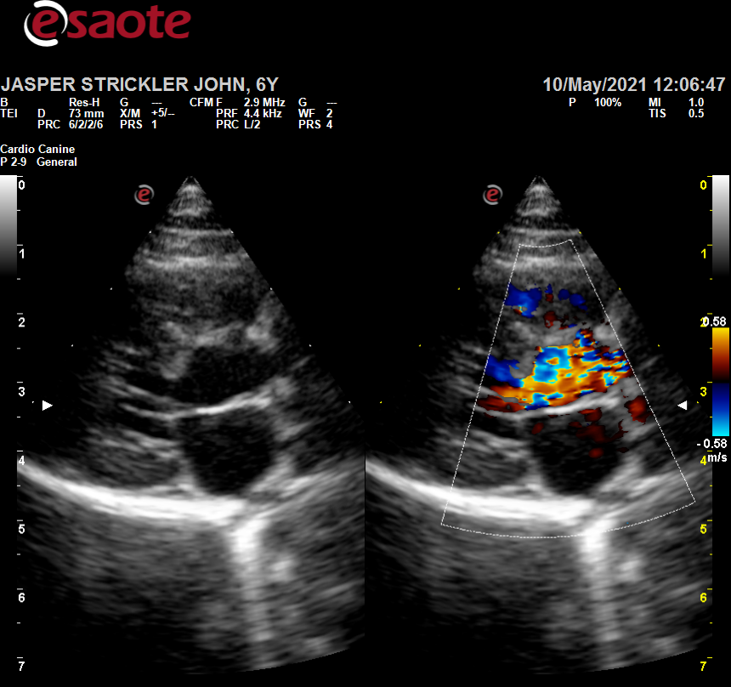

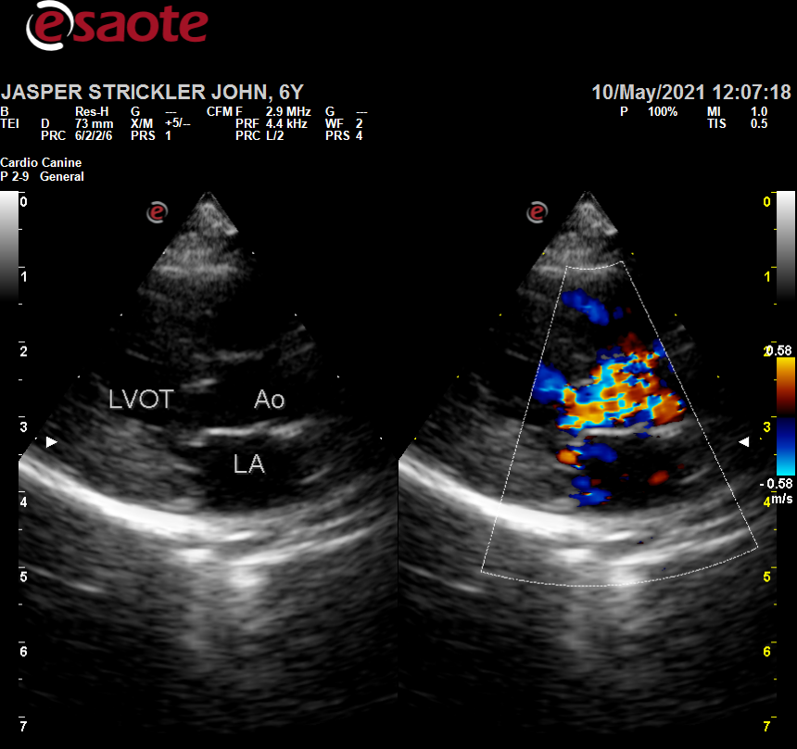 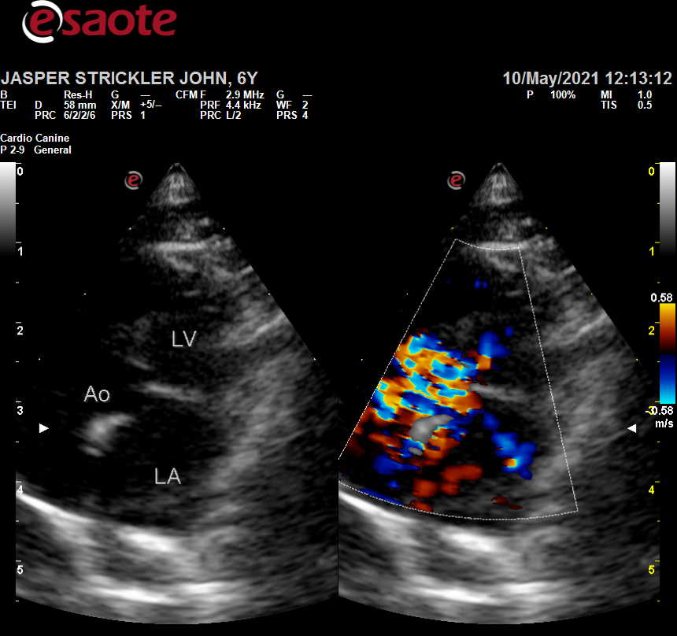

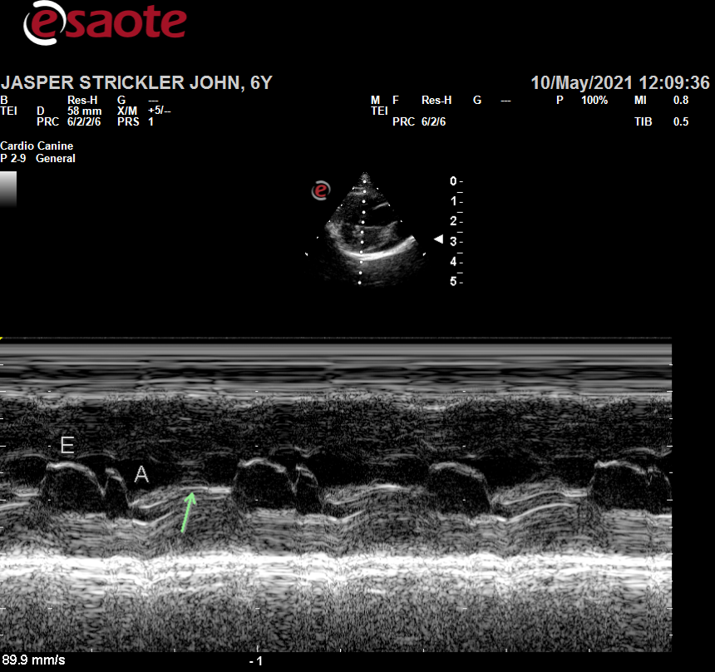 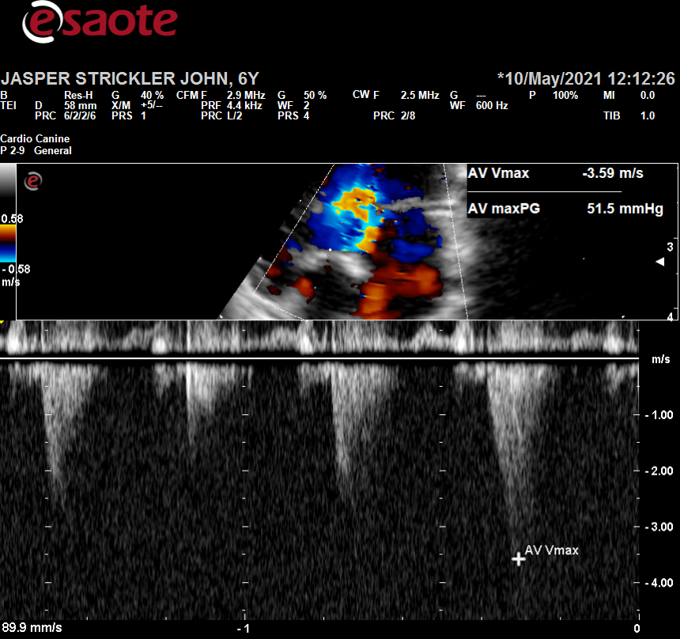

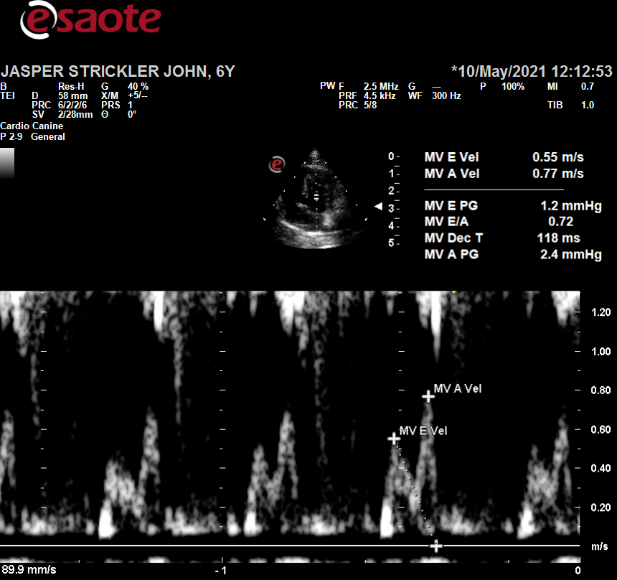

Περιγραφή: Περιγραφή: ac387Περιγραφή: Περιγραφή: ac387